Movement of lithics by trampling: An experiment in the Madjebebe sediments

Ben Marwick

Elspeth Hayes

Chris Clarkson

Richard Fullagar

2016-09-02

This is the abstract.

# Introduction

Claims for the first evidence of human activity at many archaeological sites depend on a close stratigraphic assocation between culturally modified materials and dated materials. This has been a central concern in debates surrounding the timing of the first human occupation of Sahul, where the archaeological deposits are often sandy and lacking well-defined stratigraphy. Investigations at archaeological sites in northern Australia recovered small numbers of flaked stone artefacts from sandy rockshelter deposits associated with Optically Stimulated Lumincence ages 50-60 k BP. The reliability of these associations have been questioned, with critics claiming that post-depositional processes have brought the stone artefacts in association with much older sediments. At Madjebebe (formerly Malakanunja II), one of Australia's oldest sites, trampling of artefacts has been frequently proposed as a possible cause of dislocation of artefacts through down through the deposit into an association with sediments much older than the artefacts. In this paper we describe a trampling experiment directly relevant to Madjebebe and other sites with sandy deposits, such in coastal or desert environments.

Because of the importance of its effect on the understanding artefact contexts and associations, trampling experiments are a mainstay of archaeological science. For example, Eren et al. (2010) summarised fourteen publications of trampling experiments, all aimed at understanidng how a human and animal trampling contribute to the spatial displacement of, and damage to, object commonly found in archaeological sites. The aim of our experiment was to understand how artefacts move in a sandy deposit when trampled by walking. Specifically, we explored the relationship between artefact shape paramteters and the distance they are moved by trampling. We follow Eren et al. (2010) in focusing on short-term trampling events, and by record the position, orientation and inclination of the artefacts between each trampling event.

The design of our experiment includes two novel elements not seen in previous trampling studies. First, the substrate for our trampling experiment was the same sediment as the archaeological site that motivated the experiment. A similar experimental setup was used by Benito-Calvo et al. (2011), who simulated an archaeological sediment fabric by adding clasts to a nearby non-archaeological deposit. In contrast, we conducted our trampling experiment directly on the the spoil heaps that held archaeological sediment removed during the 2012 excavations at Madjebebe. This adds a degree of realism to our trampling model. Interactions between the experiment artefacts and deposit more faithfully resemble what happened in the archaeological deposit because we used the archaeological sediments as our trampling medium. This ensures a close match for texture and penetrability between the experimental setup and the archaeological site. Our experiment still has many differences from the archaeological contexts, for example we were not able to exactly match the compaction and fabric, or directional properties, of the archaeological deposits. Furthermore, we cannot be sure of the nature of the archaeological sediment at the time the artefacts were deposited and trampled in prehistory, because post-depositional processes have likely altered the However, our field observations were that the spoil heaps closely resembled the structure, cohesiveness, permeability and moisture content of the archaeological deposits at Madjebebe.

Our second novel element is the use of a system for classifying artefact shape that is derived from geological studies of the effect of particle shape on their movement in sediments. Previous studies have used artefact length or mass as a proxy for artefact size to investigate the relationship between size and movement (eg. Nielsen 1991; Diane P. Gifford-Gonzalez 1985). As Eren et al. (2010) note, previous studies are not unanimous in demonstrating a relationship between artefact size and movement. This may be because length and mass by themselves are not especially sensitive variables when considering artefact movement. In studying the natural movement of clasts on the landscape, sedimentary geologists have developed a number of shape quantification systems to investigate the transport history of sediments and characterize depositional environments (Oakey et al. 2005; Woronow and Illenberger 1992; Benn, Ballantyne, and Illenberger 1992; Blott and Pye 2008). We adopted the simplest of these, the Zingg system, to quantify artefact shape and investigate its relationship with movement resulting from trampling.

# Madjedbebe

Previously known as Malakanunja II, Madjebebe is a sandstone rockshelter at the edge of the Magella floodplain in the Northern Territory, Australia. Archaeological excavations were conducted at Madjebebe in 1973 (Kamminga, Allen, and Study 1973), 1989 (R. G. Roberts, Jones, and Smith 1990; Clarkson et al. 2015), 2012 and 2015. The 1989 excavation produced Thermoluminescence (TL) and Optically Stimulated Luminescence (OSL) ages of 52 $±$ 11 and 61 $±$ 13 ka associated with the lowest artefacts in the deposit (R. G. Roberts, Jones, and Smith 1990). The nearby site of Nauwalabila returned similar OSL ages, bracketing the ages of the lowest artefacts at between 53 $±$ 5 and 60.3 $±$ 6 ka (Roberts et al. 1994; Bird et al. 2002). These dates were questioned by Hiscock (1990) and Bowdler (1991), and later by Allen and O'Connell (2003) and Allen and O'Connell (2014). We have previously discussed these concerns in detail in Clarkson et al. (2015). Here we focus only on Hiscock's suggestion of the possibility of downward displacement of artefacts into sterile layers through human treadage.

Hiscock cited previous work (eg. Stockton 1973) that documented vertical movement of artefacts in the range of 20-40 cm. If movements of this magnitude are common in sandy deposits such as Madjedbebe, then the artefacts associated with the 52 and 61 ka BP dates may have originally been deposited on a much younger occupational surface, and then been displaced downward into older deposits that are unrelated to human occupation. Hiscock's suggestion is that, for example, an artefact at the level of the 52 ka date, 242 cm below the surface, may have originally been deposited during occupation at c. 200 cm below. Using a loess regression on the dates published in Clarkson et al. (2015), we can interpolate a calibrated age of 23.3 ka BP for 200 cm below the surface. The difference in age of 29,000 years between 242 and 200 cm below the surface is substantial, and the ages at each depth have very different implications for the how we interpret the stone artefact assemblage.

Previously, we reported on two factors that suggest this kind of downward displacement has not been extensive at Madjedbebe (Clarkson et al. 2015). First, we noted there there are several artefacts found within the same excavation unit that conjoin. We take these conjoins as evidence that downward displacement has had only a small effect on this assemblage. Second, we showed that there are clear changes in the abundance of raw materials over time. These changes would be heavily obscured if there was substantial downward displacement of artefacts at Madjedbebe. We believe it is unlikely that the all the artefacts associated with the 52 ka date are actually 23.3 ka old, we recognise the potential for movement. However, we recognise the potential for artefact movement at the scale described by Hiscock, and with this experiment we intended to get a better understanding of what components of the lithic assemblage are most suceptible to this kind of downward displacement, and how much of the assemblage was displaced to this extent.

# Materials and methods

## Lithic assemblage

We collected nodules of white quartz from the landscape and used hard-hammer direct percussion techniques to remove flakes, following a multi-platform reduction pattern. Quartz nodules occur in the local sandstone scarp formation. Quartz artefacts are abundant in the archaeological deposit, especially in the Holocene levels. We randomly selected 30 flakes for the experiment, spray-painted the artefacts bright orange and numbered them to make them easy to identify after each trampling event. Metric data from the artefacts recovered in 1989 are not available, but we produced the artefacts to be within the size range of the artefacts we were recovering from the 2012 excavations (analysis of these artefacts is in progress).

## Shape measurement

The overall shape of a clastic particle, such an artefact, is difficult to conveniently reduce to a single measurement with precision and accuracy. In attempting to summarise an artefact's shape, archaeologists have developed a variety of methods for producing multivariate descriptions of artefact shape in two- and three-dimensions (eg. Grosman, Smikt, and Smilansky 2008; Lycett, Cramon-Taubadel, and Foley 2006). While these methods have provided insights into reduction strategies and assemblage comparison, they require specialised equipment (such as a three-dimensional scanner or photogrammetry equipment) that was not available to us for our experiment. Instead, we used linear measurements of artefacts obtained with vernier callipers to compute indices of artefact shape. These linear measurements can be used with th Zingg system to summarize artefact shape. Although there is extensive discussion on the question of the best clast shape classification method amongst geologists, there is little agreement (Woronow and Illenberger 1992; Blott and Pye 2008). We chose the Zingg because it is the simplest and most widely used shape classification system for geological clasts.

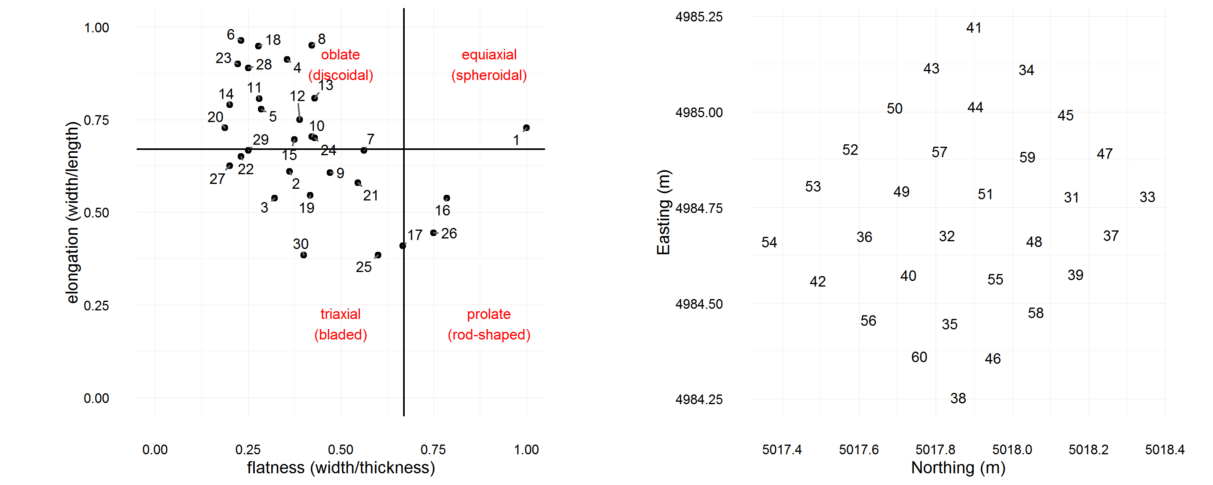

Figure 1: Left: Zingg Diagram classifying the shape of the experimental artefacts. Right: Starting locations of the experimental artefacts before trampling.

Zingg indices are derived from the measurement of the three principal axes of the approximating tri-axial ellipsoid. The three principal axes are the longest axis (denoted a *a*), the second longest axis perpendicular to the longest axis (*b*), and the third longest axis perpendicular to both *a* and *b* (denoted as *c*). These measurements are not oriented with respect to the percussion axis of the artefact. This is because the percussion attributes have little relevance to how the artefact interacts with the sedimentary deposit during trampling. We simply measured the longest axis on the artefact without regard to the flaking attributes, and then the longest axis that is perpendicular to the first axis (the intermediate axis), and then the longest axis perpendicular to that (the short axis). To obtain the Zingg indices for a given artefact, we first determined the directions for principal axes of the artefact, then measured the axes, and finally computed the axis ratios *b*/*a* (Zingg's elongation ratio) and *c*/*b* (Zingg's flatness ratio). Zingg's shape factor is elongation divided by flatness. The Zingg classifications of the artefacts used in the trampling experiment are presented in Figure 1.



Figure 2: Views of the trampling area on the excavation spoil heaps.



Figure 3: Close-up of trampling area showing the arrangement of artefacts before trampling (left, grid spacing in 10 cm) and after five minutes (right, scale rod bars are 10 cm)

## Trampling area, setup and events

The trampling area was a level surface on the spoil heap of sediment removed during the 2012 excavations at Madjebebe (Figure 2). After excavation, the sediment was sieved through 7 mm and 3 mm sieves and dumped in a pile where it was stored until the excavation was backfilled. We used shovels to create a level surface on the spoil heap of about three by three meters. We waited until near the end of the excavation so that the trampling experiment could be conducted on sediments removed from the lowest artefact-bearing deposits at Madjebebe. Waiting until the end of the excavation imposed time constraints on the experiment, limiting the scale of our study, because our excavation permit required immediate backfilling at the end of the field season.

The artefacts were arranged on a one meter grid in the centre of the trampling area (Figure 3). The artefacts were positioned 10 cm from each other. The location of the artefacts was recorded with a total station after they were placed on the grid, and after each trampling event. Of the thirty artefacts, 12 were over two centimenters long and recorded using two points at either end of their longest axis. The remaining 18 were recorded with a single point at their center of mass.

Each trampling episode consisted of an adult male walking barefoot at a constant natural slow walking speed. Our subject walked continuously in a clockwise circuit that included the trampling area for five minutes for each event. The walker crossed the trampling area in the same direction each time. At the end of five minutes, we carefully exposed the artefacts in situ with small leaf trowels, and used a total station to record their location, and for the larger ones, orientation and inclination.

## Trampling substrate

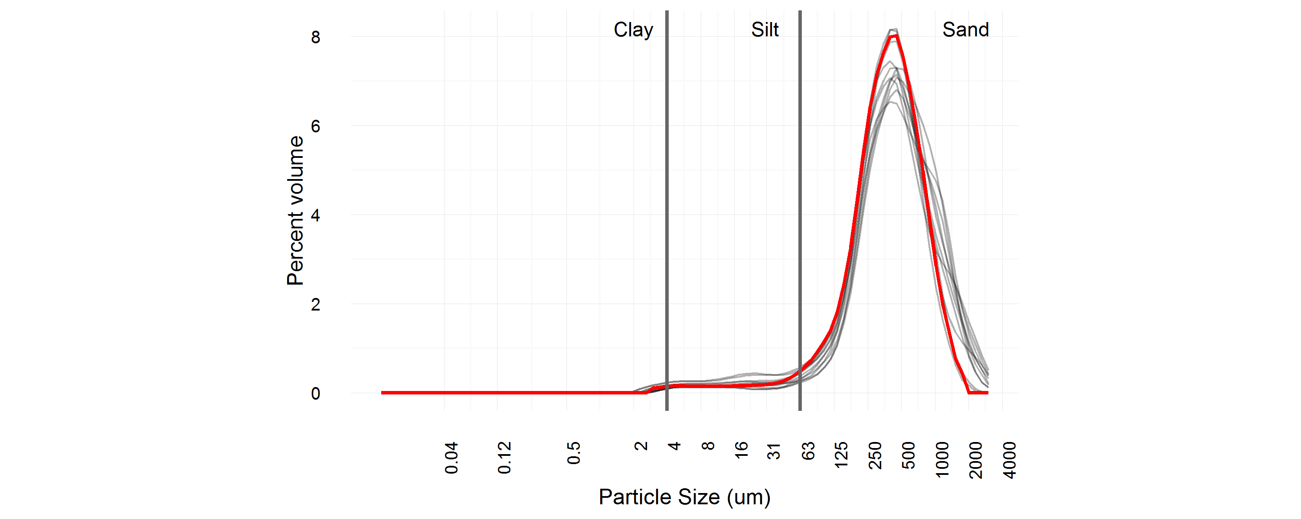

Figure 4: Particle size distributions of sediment collected from the trampling area (bold red line) and sediment collected from the archaeological excvation, 3-4 m below the surface

The trampling area was a levelled section of the excavation spoil heap. The sediments came from 3-4 m below the surface, and had passed through 7 mm and 3 mm sieves before being dumped on the spoil heap. Although the sediment has been seived, the texture of a sample take from tbe spoil head sediment remains identical to samples taken from the archaeological deposit, 3-4m below the surface (Figure 4). A permutation test for significant differences between any of these samples returns a p-value of 1 (99% confidence interval: 0.999- 0.999 estimated from 10,000 Monte Carlo replications).

# Results

We have archived the data resulting from the experiment at <doi:XXXXX> to enable inspection and resuse of our data and methods. To facilitate computational repoducibility according to the principles described in (Marwick 2016), we have also included in that compendium the R code used to analyse the data and generate the all results presented here.

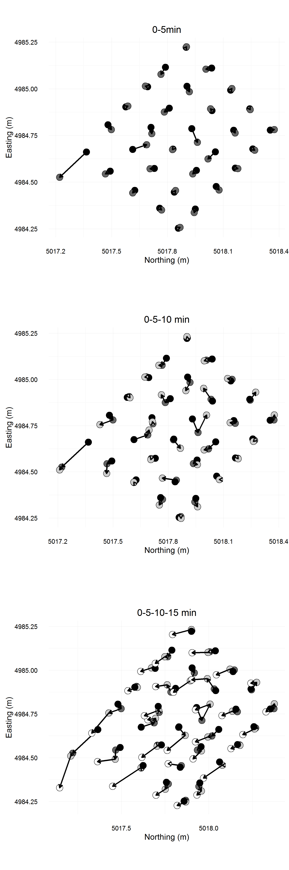

Figure 5: Plots of horizontal displacement of artefacts after 5, 10 and 15 minutes of trampling.

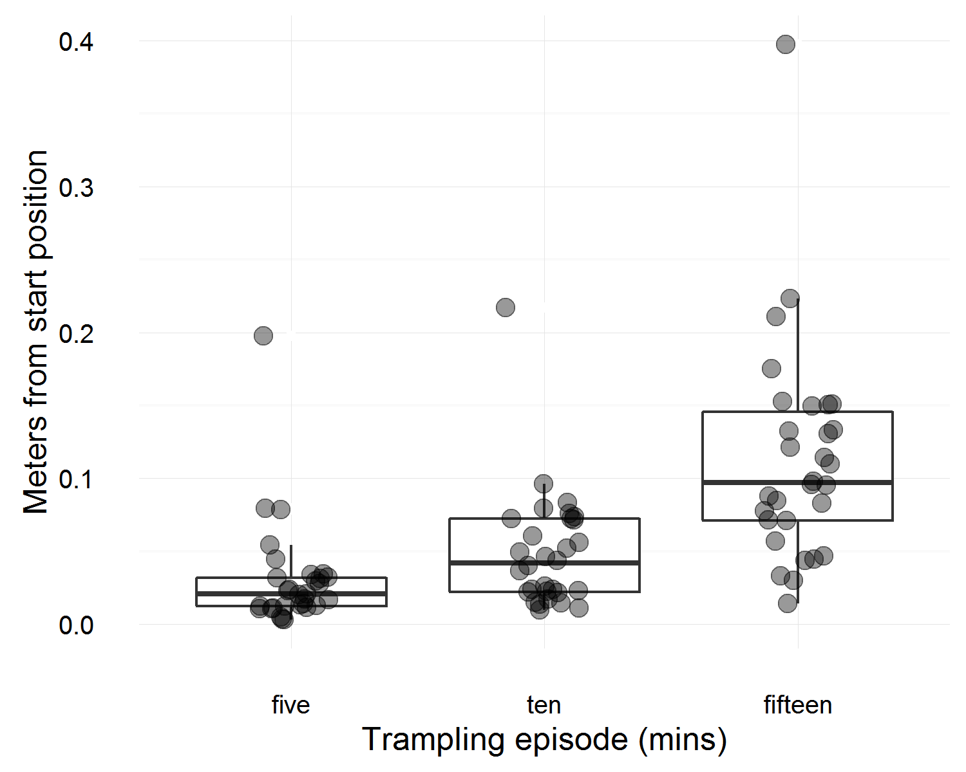

Figure 6: Distributions of horizontal displacements of artefacts after 5, 10 and 15 minutes of trampling.

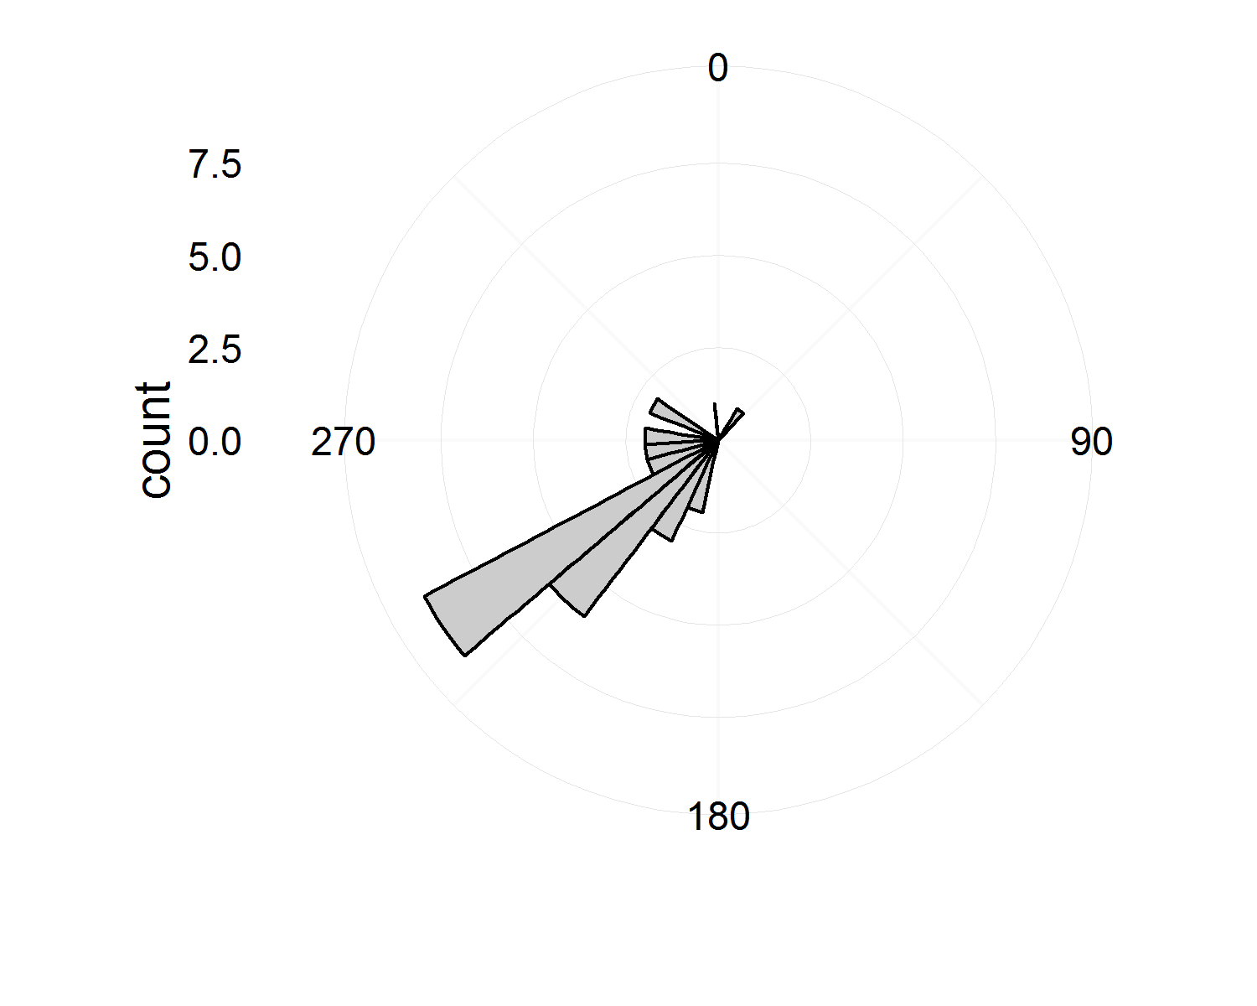

Figure 7: Histogram of directions of displacement of artefacts from their starting positions to their locations after fifteen minutes of trampling. Zero degrees is due North.

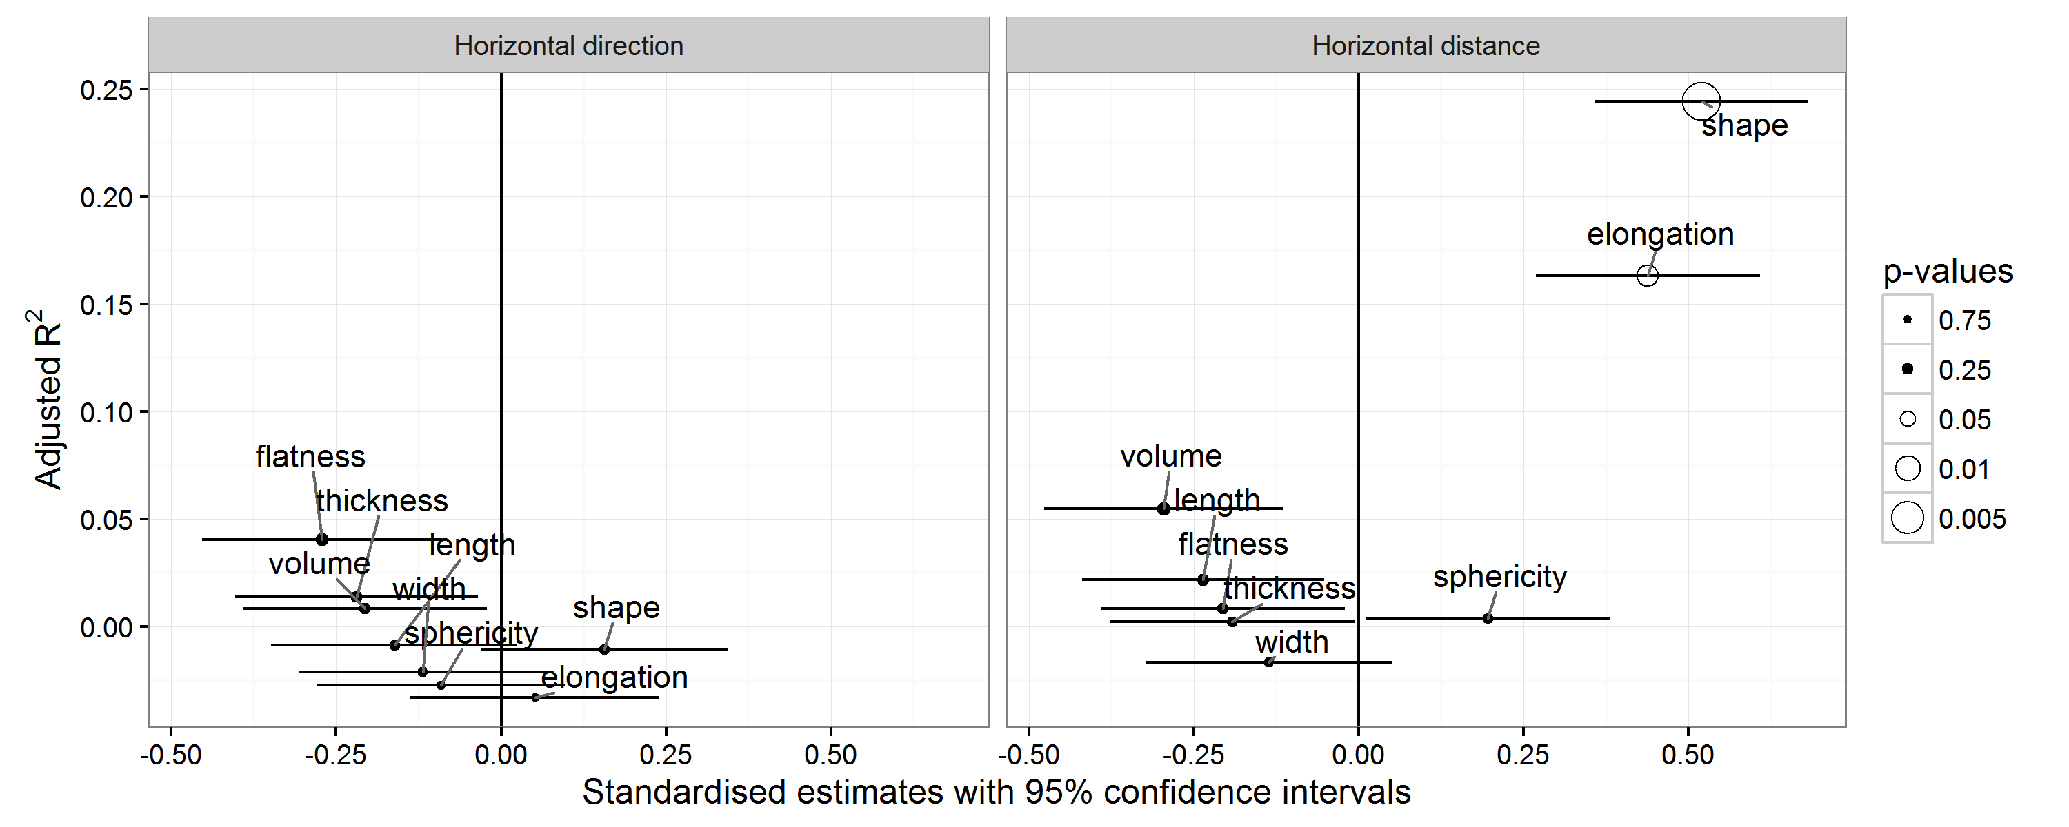

Figure 8: Linear models for a variety of predictors of the direction of horizontal direction (left) and distance (right) after fifteen minutes of trampling. Hollow data points indicate p < 0.05. Positive estimate values indicate positive correlations.

## Horizonal displacement

Figure 5 shows maps of the horizontal displacement of artefacts after five, ten and fifteen minutes. A variety of trajectories are visible, with some artefacts moving in a relatively straight line, others changing direction at each move, and one returning almost exactly to its start position. Figure 7 shows that after fifteen minutes, most artefacts have moved to a location opposite to the direction of walking across the area. None of the Zingg shape variables are effective predictors of the direction of horizontal displacement (Figure 8).

Figure 6 shows the distributions of displacements from each artefact's starting position after each trampling interval. After fifteen minutes, the total horizontal displacement of all artefacts varied from 0.014 m to 0.397 m with a median of 0.097 m, and median absolute deviation (a robust measure of variation) of 0.057 m. Figure 8 provides a graphical summary of linear regression models to identify how well the Zingg shape attributes predict the amount of horizontal displacement for each artefact after fifteen minutes of trampling. Shape and elongation are the strongest predictors of horizontal displacement. The elongation relationship indicates that as width increases relative to length, the artefacts are more likely to be moved a longer distance by trampling. The shape relationship suggests that as artefacts are more disc-like, they tend to be moved horizontally further by trampling.

## Vertical displacement

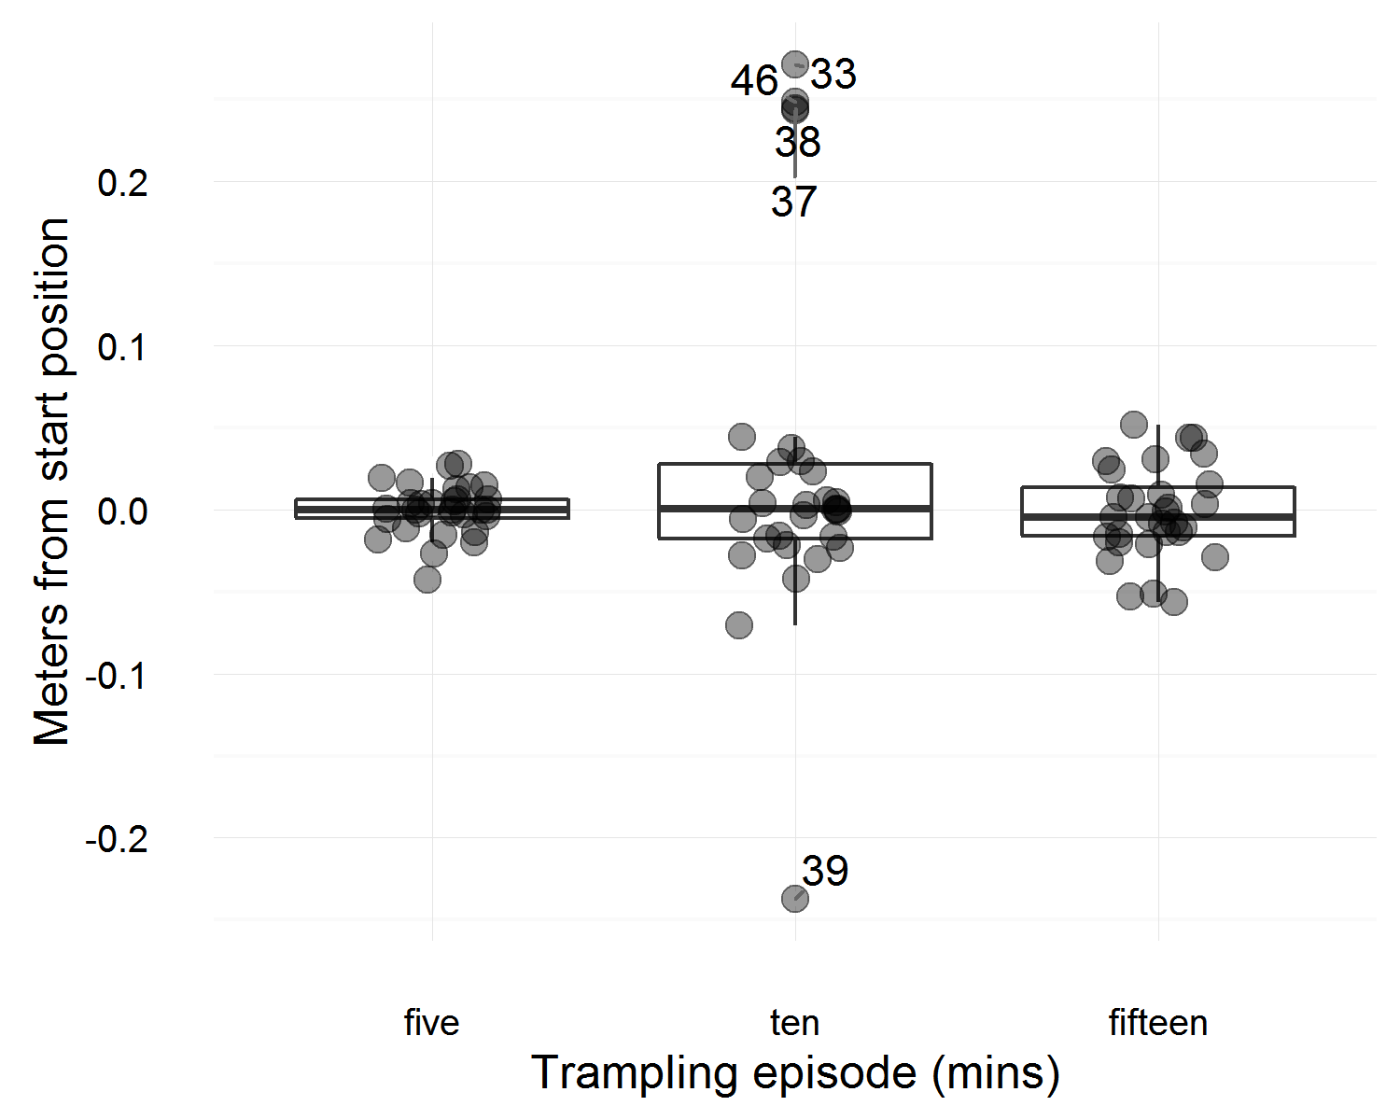

Figure 9: Distributions of vertical displacements of artefacts from their initial location to their location after 5, 10 and 15 minutes of trampling. Negative values indicate that the artefact is below its starting location.

The distributions of vertical displacements are shown in Figure 9. Five artefacts stand out as outliers, having moved > 0.2 m from their starting positions after ten minutes of trampling. These artefacts are located on the edge of the trampling area (Figure 1) and their high vertical displacement is a result of heavier steps taken while walking over the edge of the trampling area as the walker adjusted their stride after ascended the slope onto the sand pile where the trampling area was located. At the end of the third trampling episode these outlying artefacts had returned closer to their starting locations, in part because the trampling moved them horizontally further from the edge of the trampling area and away from the slope. Excuding these outliers, the vertical displacement of the artefacts is summarised in Table 1.

Table 1: Summary of absolute (ie unsigned) vertical displacement of trampled artefacts (units are meters, MAD = median absolute deviation)

|  |  |  |  |  |
| --- | --- | --- | --- | --- |
| time | Minimum | Maximum | Median | MAD |
| five | 0.000 | 0.043 | 0.006 | 0.009 |
| ten | 0.000 | 0.071 | 0.018 | 0.018 |
| fifteen | 0.001 | 0.056 | 0.016 | 0.016 |

Figure 10 shows that unsigned (or absolute, without respect to the upwards or downwards direction) vertical displacement is most strongly influenced by artefact shape. Shape is elongation divided by flatness, so this means that disc-like artefacts have higher magnitudes of vertical movement relative to other artefact shapes. However, shape is relatively unimportant when considering signed (or directional) displacement. Artefact volume, width, length and thickness are all signficant predictors when the direction of vertical movement is considered. Bigger artefacts tend to move above their starting position, and smaller artefacts tend to move below it.

The vertical angles of artefact displacement cluster close to horizontal (Figure 11). This is expected given that the horizontal displacement values are much greater than the vertical displacement values.

Correlation of ver with hor displs

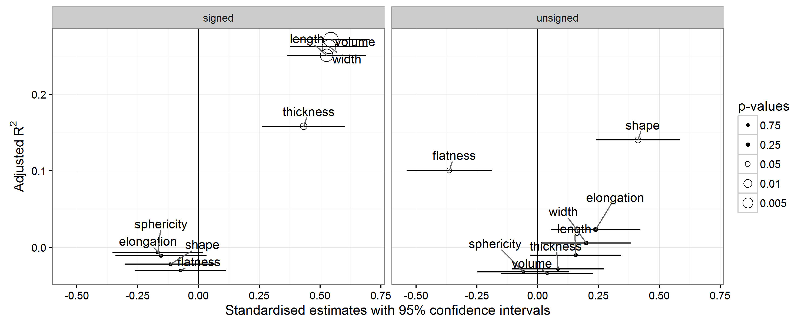

Figure 10: Linear models for a variety of predictors of signed and unsigned (ie. absolute) vertical displacement after fifteen minutes of trampling. Hollow data points indicate p < 0.05. Positive estimate values indicate positive correlations.

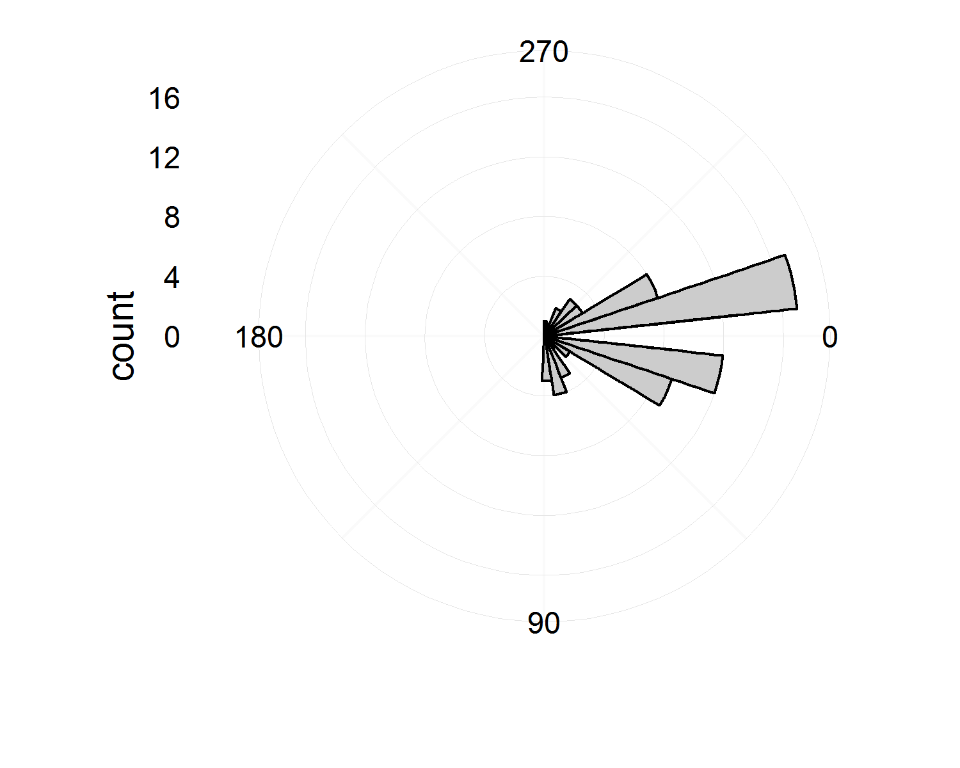

Figure 11: Vertical angles of artefact displacement, or the vertical angle that the artefact moved from its starting point to its location after each trampling event. Zero degrees is horizontal

## artefact angle_hor_displacement  
## 1 39 239.1420  
## 2 43 231.5498  
## 3 44 217.6107  
## 4 47 358.8275  
## 5 48 241.9679  
## 6 50 258.3707  
## 7 51 209.5812  
## 8 52 242.3800  
## 9 53 222.0724  
## 10 54 213.4186  
## 11 55 213.1608  
## 12 56 235.6923  
## 13 57 275.0756  
## 14 58 224.8817  
## 15 59 294.4730  
## 16 60 219.3840  
## 17 33 231.2384  
## 18 34 273.6597  
## 19 35 295.6209  
## 20 36 41.5799  
## 21 37 233.3386  
## 22 38 225.5974  
## 23 40 239.2657  
## 24 41 264.4044  
## 25 42 237.2223  
## 26 45 251.3334  
## 27 46 202.4325  
## 28 49 241.2943  
## 29 31 218.0483  
## 30 32 202.3952

## Orientation and Plunge

Our sample includes 14 artefacts with two or four total station points, enabling measurements of changes in the orientation of the artefact (ie. changes in the bearing of the long axis of the artefact) and plunge (ie. the vertical angle from the horizontal plane of the long axis of the artefact). Figure 12 shows that these changes are generally small, with most changes clustered around zero degrees (ie the bearing/plunge angle that the artefact was at before trampling). Only changes in orientation are significantly predicted by artefact shape and size attributes; there are no significant predictors for changes in artefact plunge angle (Figure 13). Similar to vertical displacement, artefact volume, width, length and thickness are all significant predictors of the magnitude of change in artefact orientation. Bigger artefacts tend to be rotated further from their original bearing.

Correlations of these changes in orientaton and plunge with horizontal and vertical distances and angles are shown in Table 2. Orientation and plunge are not strongly correlated with any other measurements of artefact movement. Increased distances of artefact displacement do not appear to have any effect on artefact orientation and plunge. Vertical angle is strongly negatively correlated with horizontal distance and vertical distance. This indicates that as the artefact moves further from its starting location, the vertical angle is smaller (i.e. closer to horizontal). Vertical and horizontal distance have a moderately strong positive relationship, indicating that the magnitude of displacement is proportional in both horizontal and vertical axes.

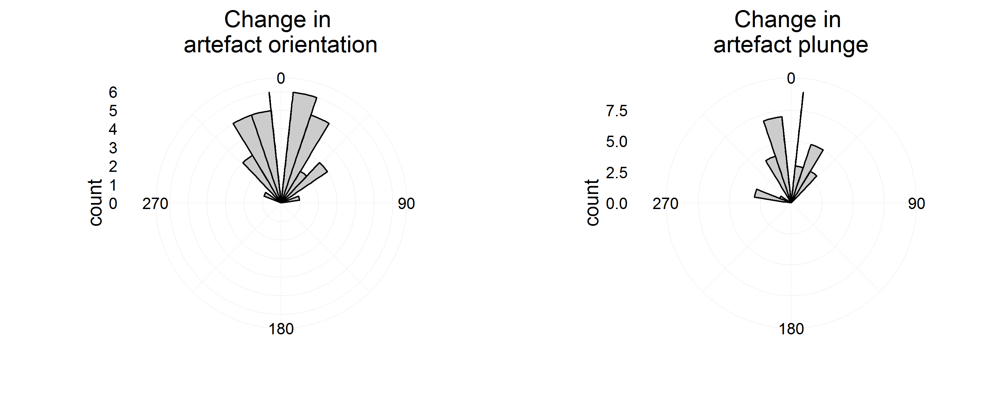

Figure 12: Histograms of changes in artefact orientation (left) and artefact plunge (right) after each trampling event. Zero degrees refers to the starting orientation bearing or plunge angle for each artefact. For artefact plunge, a change 0-180 degrees is a change towards a more vertical orientation, and a change 180-360 is a change towards a more horizontal orientation.

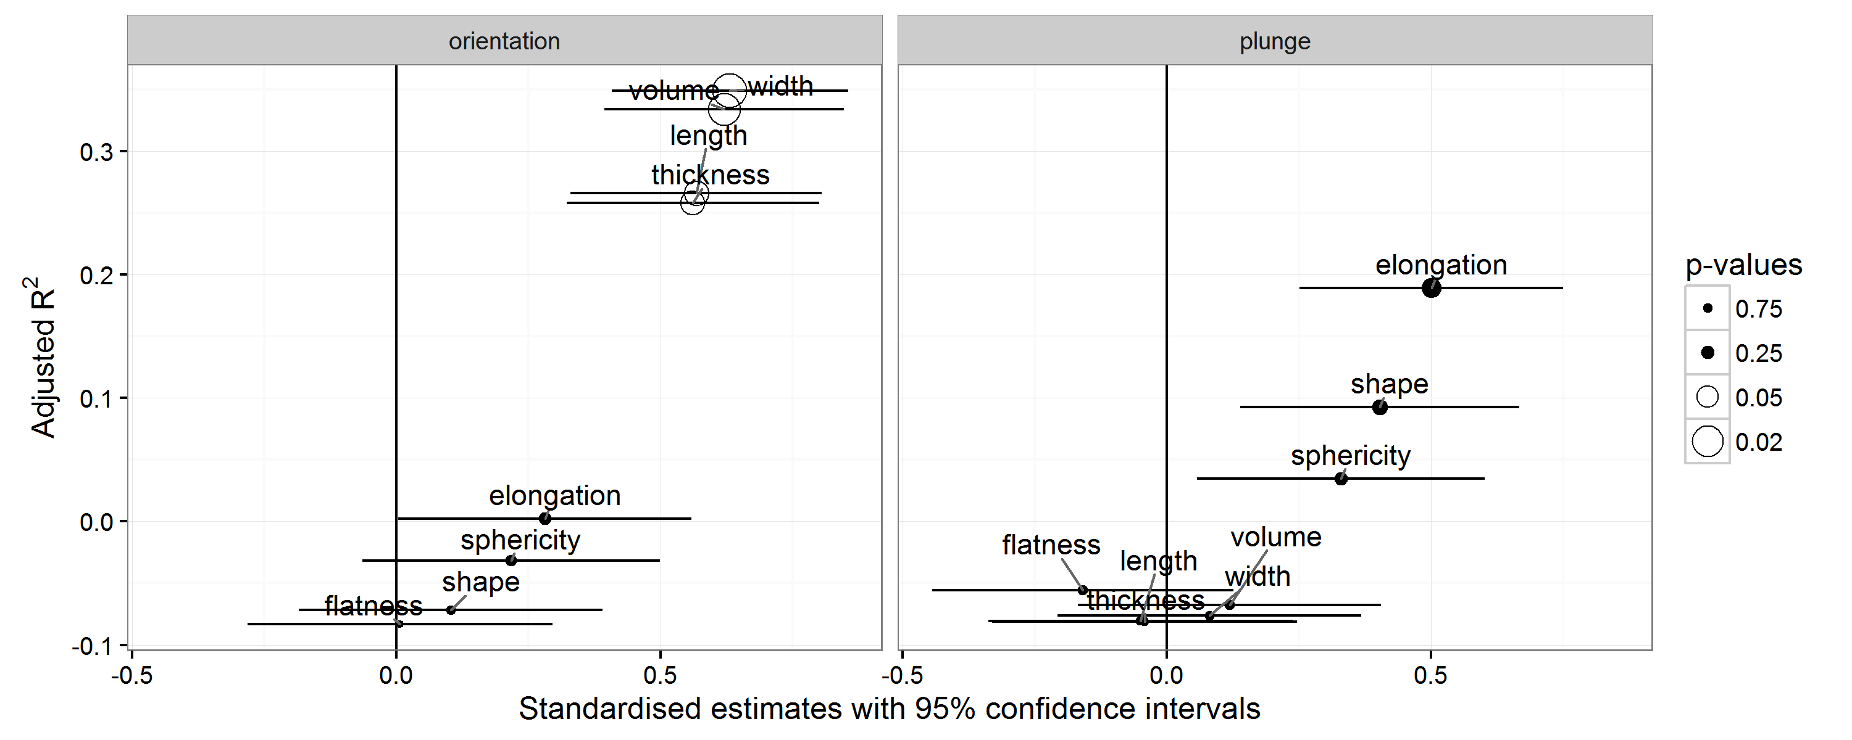

Figure 13: Linear models for a variety of predictors of changes in artefact orientation bearing and plunge angle after fifteen minutes of trampling. Hollow data points indicate p < 0.05. Positive estimate values indicate positive correlations.

Table 2: Pearson's correlation coefficients for changes in artefact plunge and orientation, and for values of horizontal and vertical distance, horizontal bearing and verticle angle after fifteen minutes. Values in parentheses are p-values. Strong significant correlations are in bold.

|  |  |  |  |  |  |
| --- | --- | --- | --- | --- | --- |
|  | Plunge | Horizontal distance | Horizontal bearing | Vertical distance | Vertical angle |
| Orientation | -0.02 (0.94) | 0.1 (0.74) | -0.22 (0.44) | 0.11 (0.71) | -0.15 (0.61) |
| Plunge |  | 0.28 (0.33) | 0.37 (0.19) | 0.33 (0.25) | -0.31 (0.28) |
| Horizontal distance |  |  | 0.27 (0.35) | 0.62 (0.02) | **-0.74 (0)** |
| Horizontal bearing |  |  |  | 0.49 (0.07) | -0.44 (0.12) |
| Vertical distance |  |  |  |  | **-0.88 (0)** |

# Discussion

...compare to results of other studies...

## Simulation by resampling

simulation or 1000s of trampling events by resampling bearing, hor-distance and ver-distance (independantly of each trampling event measurement) for each artefact to move it to new but plausible locations

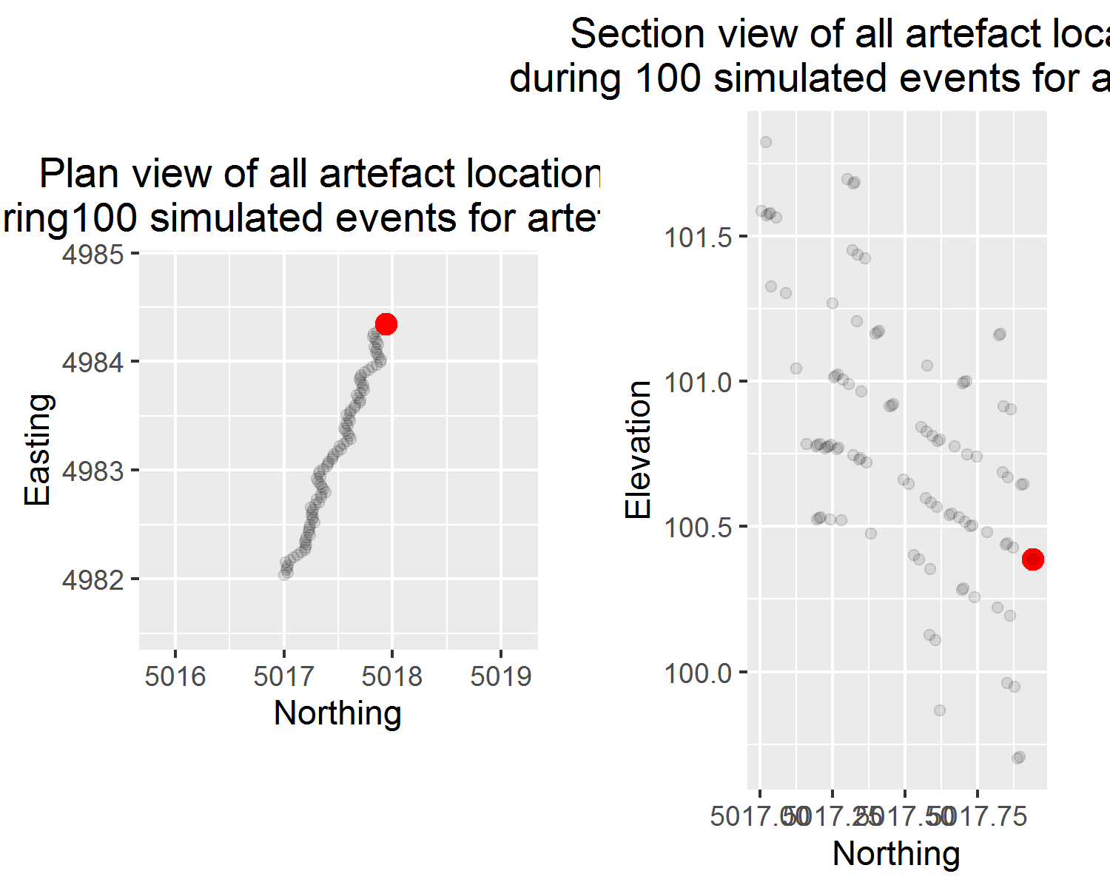

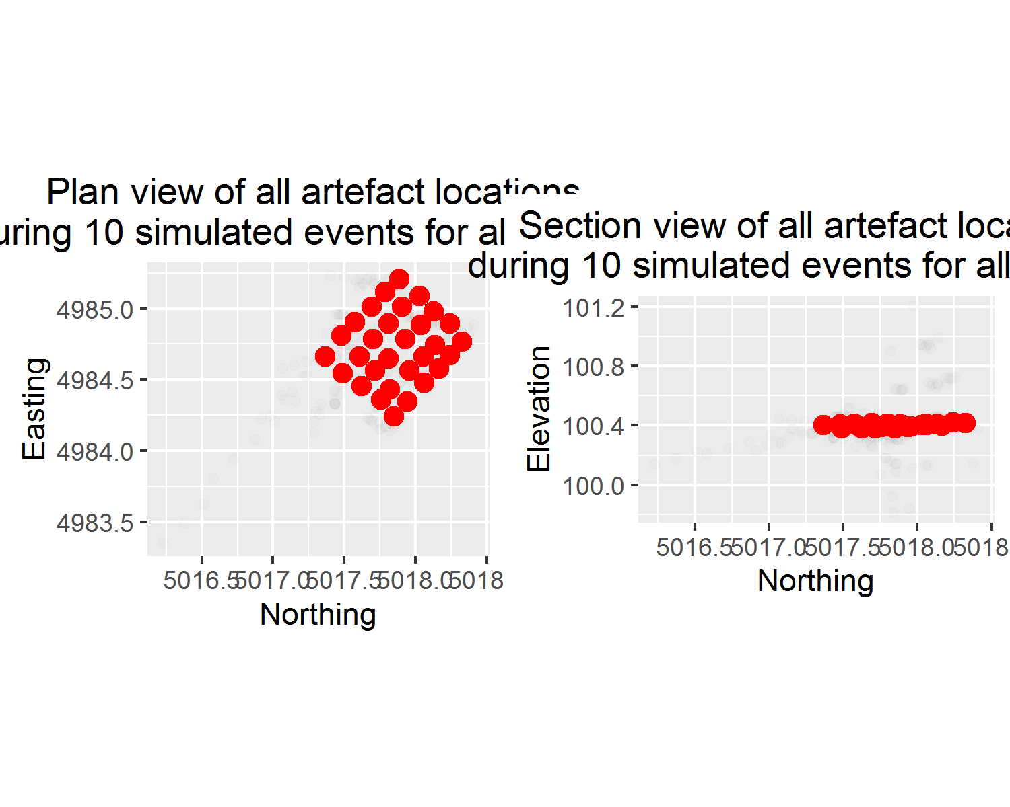

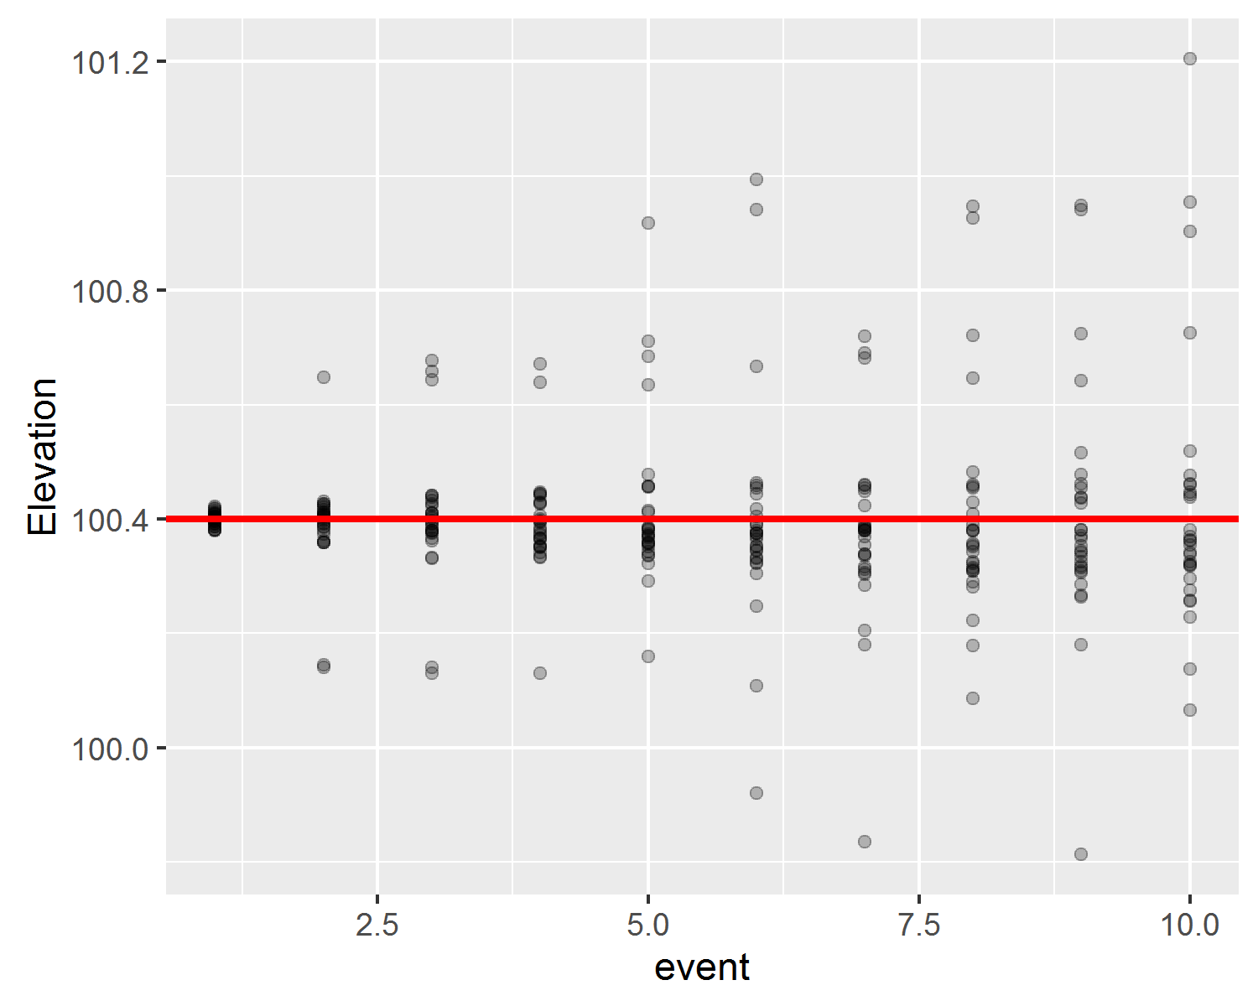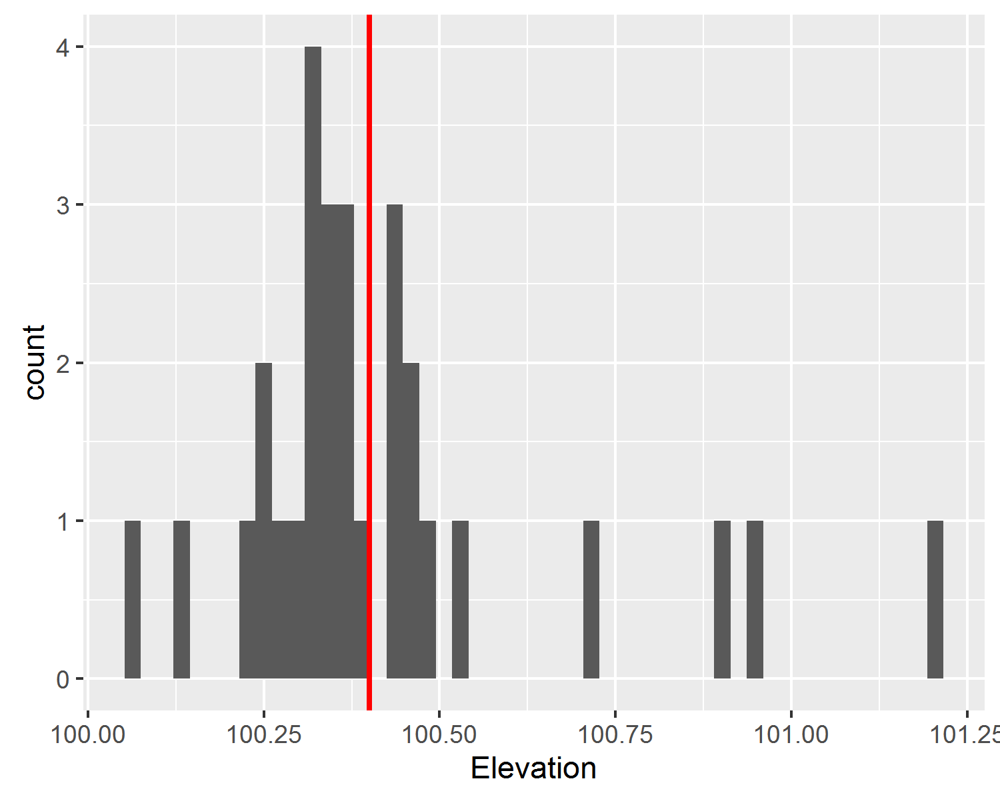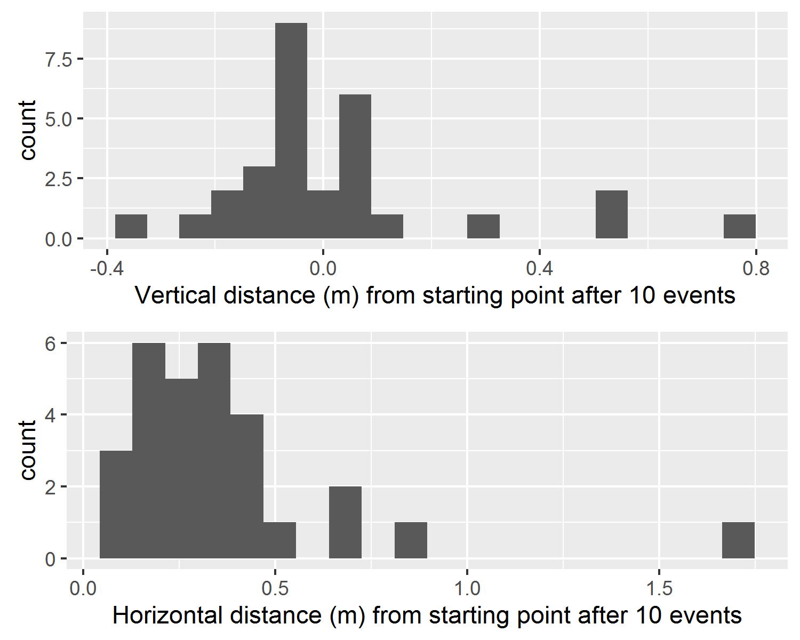

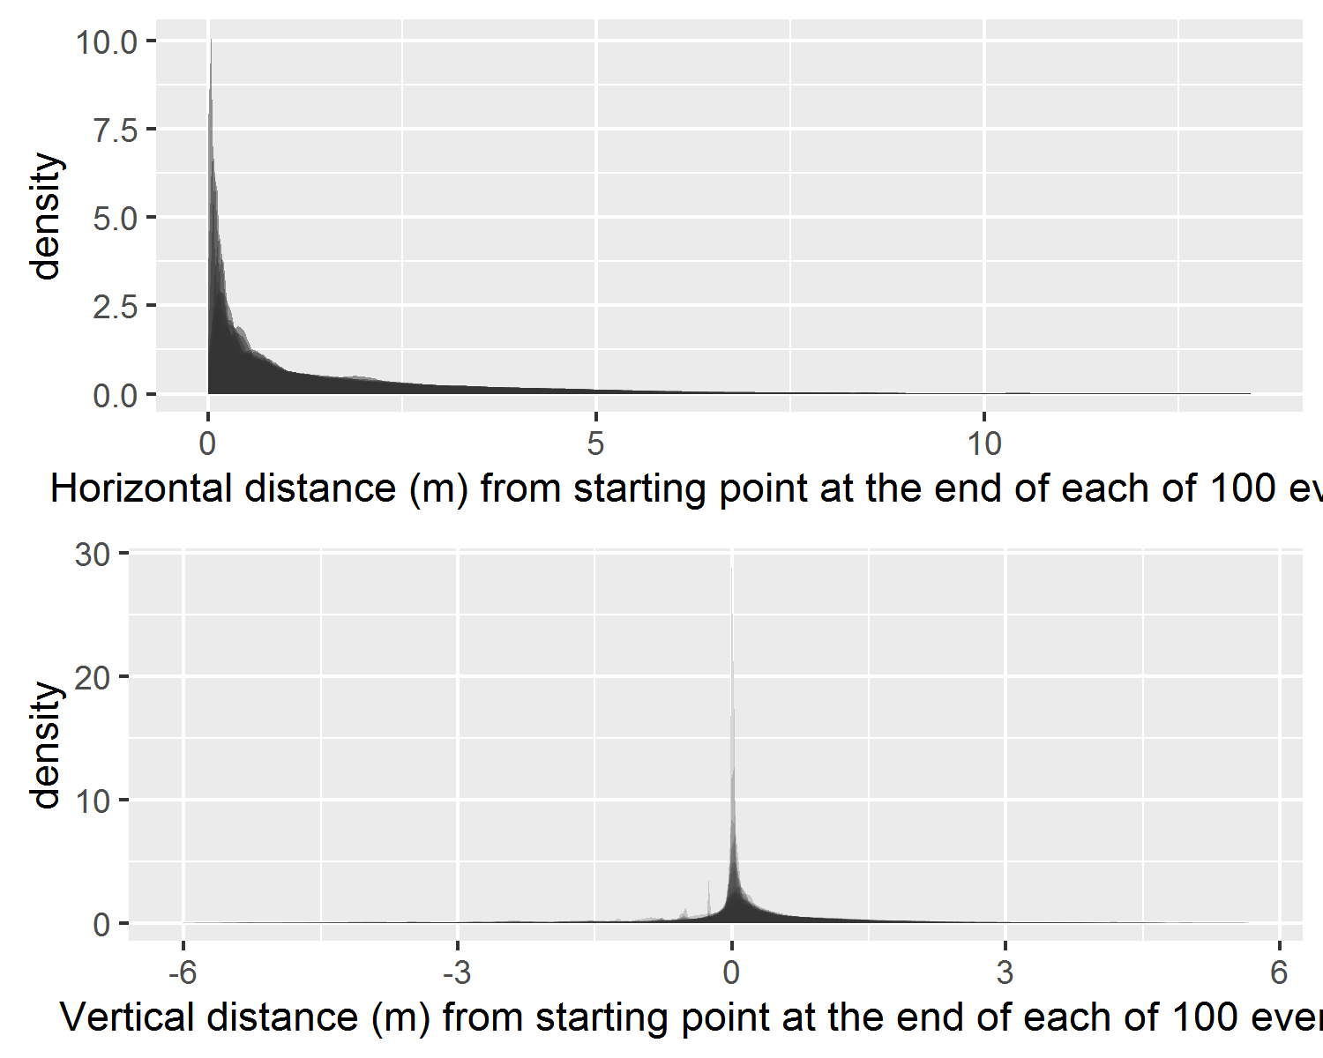

# Conclusion

# References

Allen, Jim, and James F. O’Connell. 2003. “The Long and the Short of It, Archaeological Approaches to Determining When Humans First Colonised Australia and New Guinea.” Journal Article. *Australian Archaeology*, no. 57: 5–19. [http://search.informit.com.au/fullText;res=APAFT;dn=200407738](http://search.informit.com.au/fullText;res=APAFT;dn=200407738 ).

———. 2014. “Both Half Right: Updating the Evidence for Dating First Human Arrivals in Sahul.” *Australian Archaeology*, no. 79. Australian Archaeological Association Inc.: 86–108.

Benito-Calvo, Alfonso, Jorge Martínez-Moreno, Rafael Mora, Miquel Roy, and Xavier Roda. 2011. “Trampling Experiments at Cova Gran de Santa Linya, Pre-Pyrenees, Spain: Their Relevance for Archaeological Fabrics of the Upper–Middle Paleolithic Assemblages.” *Journal of Archaeological Science* 38 (12): 3652–61. doi:[http://dx.doi.org/10.1016/j.jas.2011.08.036](https://doi.org/http://dx.doi.org/10.1016/j.jas.2011.08.036).

Benn, Douglas I., Colin K. Ballantyne, and Werner K. Illenberger. 1992. “Pebble Shape (and Size!); Discussion and Reply.” *Journal of Sedimentary Research* 62 (6): 1147–55. <http://jsedres.sepmonline.org/content/62/6/1147.short>.

Bird, M. I., C. S. M. Turney, L. K. Fifield, R. Jones, L. K. Ayliffe, A. Palmer, R. Cresswell, and S. Robertson. 2002. “Radiocarbon Analysis of the Early Archaeological Site of Nauwalabila I, Arnhem Land, Australia: Implications for Sample Suitability and Stratigraphic Integrity.” Journal Article. *Quaternary Science Reviews* 21 (8–9): 1061–75. doi:[http://dx.doi.org/10.1016/S0277-3791(01)00058-0](https://doi.org/http://dx.doi.org/10.1016/S0277-3791(01)00058-0).

Blott, Simon J, and Kenneth Pye. 2008. “Particle Shape: A Review and New Methods of Characterization and Classification.” *Sedimentology* 55 (1). Wiley Online Library: 31–63.

Bowdler, S. 1991. “Some Sort of Dates at Malakunanja II: A Reply to Roberts et Al.” Journal Article. *Australian Archaeology* 32: 50–51.

Clarkson, Chris, Mike Smith, Ben Marwick, Richard Fullagar, Lynley A. Wallis, Patrick Faulkner, Tiina Manne, et al. 2015. “The Archaeology, Chronology and Stratigraphy of Madjedbebe (Malakunanja II): A Site in Northern Australia with Early Occupation.” *Journal of Human Evolution* 83: 46–64. doi:[http://dx.doi.org/10.1016/j.jhevol.2015.03.014](https://doi.org/http://dx.doi.org/10.1016/j.jhevol.2015.03.014).

Diane P. Gifford-Gonzalez, Debra R. Damrosch, David B. Damrosch. 1985. “The Third Dimension in Site Structure: An Experiment in Trampling and Vertical Dispersal.” *American Antiquity* 50 (4). Society for American Archaeology: 803–18. <http://www.jstor.org/stable/280169>.

Eren, Metin I, Adam Durant, Christina Neudorf, Michael Haslam, Ceri Shipton, Janardhana Bora, Ravi Korisettar, and Michael Petraglia. 2010. “Experimental Examination of Animal Trampling Effects on Artifact Movement in Dry and Water Saturated Substrates: A Test Case from South India.” *Journal of Archaeological Science* 37 (12). Elsevier: 3010–21.

Grosman, Leore, Oded Smikt, and Uzy Smilansky. 2008. “On the Application of 3-d Scanning Technology for the Documentation and Typology of Lithic Artifacts.” *Journal of Archaeological Science* 35 (12): 3101–10. doi:[http://dx.doi.org/10.1016/j.jas.2008.06.011](https://doi.org/http://dx.doi.org/10.1016/j.jas.2008.06.011).

Hiscock, P. 1990. “How Old Are the Artefacts in Malakunanja II?” Journal Article. *Archaeology in Oceania* 25: 122–24.

Kamminga, Johan, Harry Allen, and Alligator Rivers Region Environmental Fact-Finding Study. 1973. *Alligator Rivers Environmental Fact Finding Study : Report of the Archaeological Survey*. Book; Book/Illustrated. [Darwin : Government Printer for Alligator Rivers Region Environmental Fact-Finding Study].

Lycett, Stephen J., Noreen von Cramon-Taubadel, and Robert A. Foley. 2006. “A Crossbeam Co-Ordinate Caliper for the Morphometric Analysis of Lithic Nuclei: A Description, Test and Empirical Examples of Application.” *Journal of Archaeological Science* 33 (6): 847–61. doi:[http://dx.doi.org/10.1016/j.jas.2005.10.014](https://doi.org/http://dx.doi.org/10.1016/j.jas.2005.10.014).

Marwick, Ben. 2016. “Computational Reproducibility in Archaeological Research: Basic Principles and a Case Study of Their Implementation.” *Journal of Archaeological Method and Theory*. Springer US, 1–27. doi:[10.1007/s10816-015-9272-9](https://doi.org/10.1007/s10816-015-9272-9).

Nielsen, Axel E. 1991. “Trampling the Archaeological Record: An Experimental Study.” *American Antiquity* 56 (3). Society for American Archaeology: 483–503. <http://www.jstor.org/stable/280897>.

Oakey, Robert J., Michael Green, Paul A. Carling, Mark W.E. Lee, David A. Sear, and Jeff Warburton. 2005. “Grain-Shape Analysis—A New Method for Determining Representative Particle Shapes for Populations of Natural Grains.” *Journal of Sedimentary Research* 75 (6): 1065–73. doi:[10.2110/jsr.2005.079](https://doi.org/10.2110/jsr.2005.079).

Roberts, R. G., R. Jones, and M. A. Smith. 1990. “Thermoluminescence Dating of a 50,000-Year-Old Human Occupation Site in Northern Australia.” Journal Article. *Nature* 345 (6271): 153–56.

Roberts, Richard G., Rhys Jones, Nigel A. Spooner, M. J. Head, Andrew S. Murray, and M. A. Smith. 1994. “The Human Colonisation of Australia: Optical Dates of 53,000 and 60,000 Years Bracket Human Arrival at Deaf Adder Gorge, Northern Territory.” Journal Article. *Quaternary Science Reviews* 13 (5-7): 575–83. [http://www.sciencedirect.com/science/article/B6VBC-4876F0J-7G/2/515ddab0f440a1187afe34a0747c359e](http://www.sciencedirect.com/science/article/B6VBC-4876F0J-7G/2/515ddab0f440a1187afe34a0747c359e ).

Stockton, Eugene D. 1973. “Shaw’s Creek Shelter: Human Displacement of Artefacts and Its Significance.” *Mankind* 9 (2). Wiley Online Library: 112–17.

Woronow, Alex, and Werner K. Illenberger. 1992. “Pebble Shape (and Size); Discussion and Reply.” *Journal of Sedimentary Research* 62 (3): 536–40. <http://jsedres.sepmonline.org/content/62/3/536.short>.